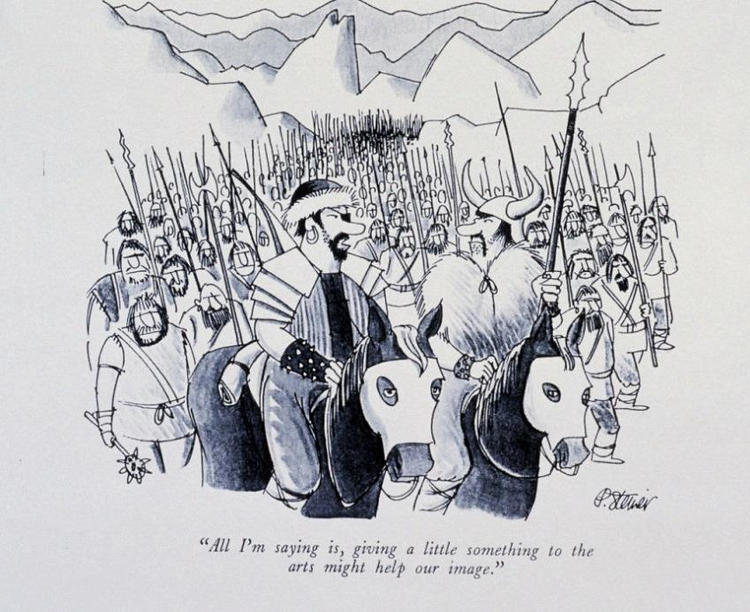**CE ( AD) 476—The fall of the ROMAN EMPIRE:**

After nearly half a millennium of rule, the Romans finally lost their grip on Europe in the fifth century (the 400's CE). Their **decline** left untold **devastation** and **political chaos**. Though Roman government in the form of the **Byzantine Empire** survived in the East for almost another thousand years, so-called barbarian forces overran western Europe, spelling the end of an era, leading to a time often called THE DARK AGES.

**Define:**

millennium: ________________________________________________________

decline: _____________________________________________________

devastation: ______________________________________________________

political chaos: _____________________________________________________

Byzantine Empire: _____________________________________________________

**WHO TOOK OVER?** ( after the Romans )…

Historians once called this time after the Roman Empire **THE DARK AGES.** Was this because all the lights went out in Europe? NO

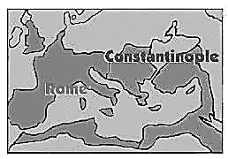

This period lasted from about 500 CE to 1000 CE

The DARK AGES was not actually a time when people lived without law. HOWEVER, there was no central government and things like art, literature, medicine and science were neglected in many areas of Europe. There was no central government to collect taxes, so roads, bridges and other public structures often decayed. People even used the stones from public buildings to make their own houses eg Hadrian’s Wall in Britain nearly disappeared.

This was a time when the strongest fighters usually became the leaders of their communities. These men often called themselves ‘lords’ and began to construct a small ‘kingdom’ around themselves. This in turn led to the development of a system of government called ‘feudalism’ where a lord ruled a village and area of land. He had soldiers at his command and he had peasant farmers who worked the land for him. If he controlled enough land, soldiers and peasants he could become a King.